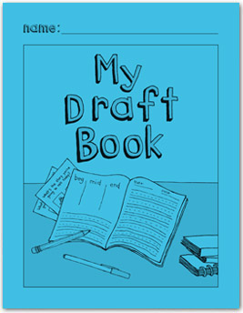

Supporting Students

Work In My Draft Book

*Getting Started*

* Designed for 1st grade students after use of My Writing Journal (Green Book)
* Used initially in small groups. As students understand the writing process, they can work more independently in the journal as teachers roam and provide support.
* Teacher confers with the student about what the *plan* will contain.
* Direct instruction focuses on elaboration, descriptive detail, vocabulary, sentence structures and text forms and features.
* Known words and word families are continually added to the first pages for the student to reference during writing.
* Use pages for the student to write down topics in narrative, information and opinion writing

*Student Writing Pages*

* Students have writing tools (green cards) available.
* Student indicates the dates for each writing session.
* Student identifies who the audience will be before writing begins.
* The plan is now a sketch with words and phrases
* Only the *important details* go in the plan, it is not an illustration.
* Line out mistakes, no erasers. This allows teachers to see “trails of thought”.
* Plan is 3- part (B-M-E) or 4 parts (B-M-M-E) according to benchmarks.
* 4-part plans focus on more details and description in the middle.
* After the student draws the plan and retells the oral story, teacher has child add any missing details/words/phrases to the plan that are critical part(s) of the story.
* The plan still contains speech or thought bubbles. These will become dialogue in the writing below and are still very important.
* Writing is carried over more than one day.
* Student self monitors by completing the “I did” portion on the bottom after every writing episode.
* Contains evidence that instruction by the teacher has occurred (editing, revision, circled misspelled sight words, adding descriptive words or stronger vocabulary).
* Some student work is taken through the publishing process with draft, editing and illustrations.

Monitoring Pages

* Initially, and periodically the teacher scores the level of the student work in an *assessment with no teacher help* and indicates the dates benchmark items are consistent in the student writing on the monitoring notes pages.
* Monitoring notes are by process, surface feature and content (narrative, explanatory/opinion.
* Use the blank areas to monitor for other items as needed.